
Backdoors and Breaches is a team-based game designed to simulate a cybersecurity incident in an engaging and educational way. Players take on the role of an organisation’s Incident Response team, working together to identify the four elements of a cyber-attack, these are:


To help identify the cyber attacks used within the scenario, the Incident Response Team has access to a range of Detection Methods, such as:
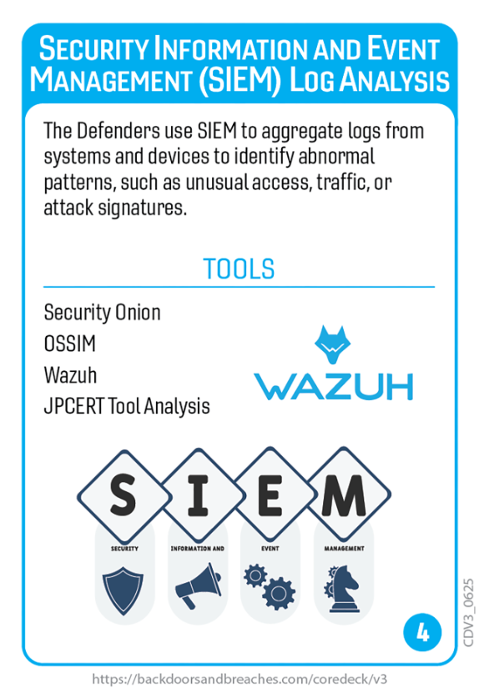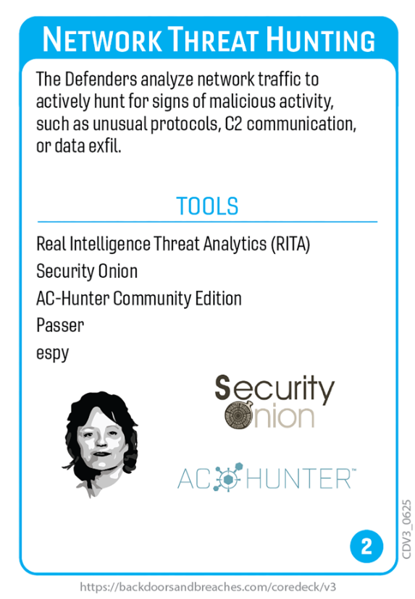
Rules:
Backdoors and Breaches is a turn-based game in which the Incident Response Team has 10 turns to solve the four-card cyber attack chain. Each turn begins with the players discussing which detection method they want to use to identify an element of the cyber attack chain, based on the incident scenario.
Once the team have decided upon a detection method the team then roll a D20 (a 20-sided die) to determine failure (1 to 10) or success (11 – 20). Established Detection methods (of which 4 are selected at the start of the game) gain a +3 modifier. Additional modifiers can be gained based on the teams understanding and reasoning shown in selecting the detection methods.
If the selected detection method succeeds (the D20 shows 11-20) and matches one of the four attack chain cards, that attack chain card is revealed and the Incident Response Team gains additional information about the incident
If a detection method is successful, it can be used again immediately. Unsuccessful detection methods become unavailable for three turns.
The process is repeated until all four attack cards are revealed (game is won) or ten turns elapsed without all four cyber-attack chain cards being revealed (game is lost).

